**JUNAID GIRKAR**

**60004190057**

**EXPERIMENT NO : 7**

**AIM: Implementation of 4x1 multiplexer and 1x4 demultiplexer using logic gates.**

Theory

**Introduction**

A **multiplexer ( or mux )**, also known as a **data selector**, is a device that selects between several analog or digital input signals and forwards it to a single output line. A multiplexer of {\displaystyle 2^{n}}n inputs has {\displaystyle n}2^n  select lines, which are used to select which input line to send to the output.

Conversely, a  **demultiplexer** (or **demux**) is a device taking a single input and selecting signals of the output of the compatible **mux**, which is connected to the single input, and a shared selection line. A multiplexer is often used with a complementary demultiplexer on the receiving end.

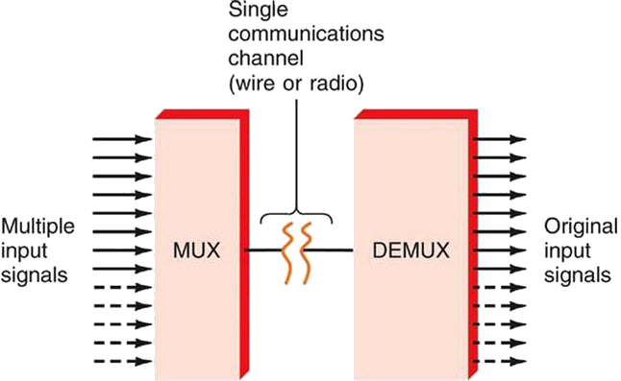  
**Figure-1:Block diagram of Multiplexer and De-multiplexer**

**1) Multiplexer**

Multiplexer is a device that has multiple inputs and a single line output. The select lines determine which input is connected to the output, and also to increase the amount of data that can be sent over a network within certain time. It is also called a data selector.

Multiplexers are classified into four types:

a) 2-1 multiplexer (1 select line)  
b) 4-1 multiplexer (2 select lines)  
c) 8-1 multiplexer(3 select lines)  
d) 16-1 multiplexer (4 select lines)

**1.1) 4x1 Multiplexer**

4x1 Multiplexer has four data inputs I3, I2, I1 & I0, two selection lines S1 & S0 and one output Y. The block diagram of 4x1 Multiplexer is shown in the following figure. One of these 4 inputs will be connected to the output based on the combination of inputs present at these two selection lines. Truth table of 4x1 Multiplexer is shown below.

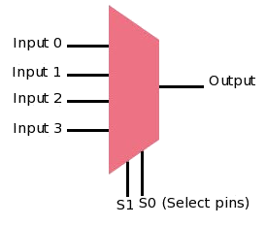 **Figure-2:Block diagram of 4x1 Multiplexer**  
  
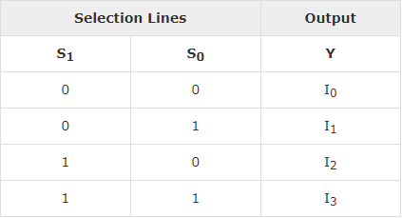  
**Figure-3:Truth table of 4x1 Multiplexer**

**2) De-multiplexer**

Demultiplexers take one data input and a number of selection inputs, and they have several outputs. They forward the data input to one of the outputs depending on the values of the selection inputs. The main difference between a multiplexer and a de-multiplexer is that a multiplexer takes two or more signals and encodes them on a wire, whereas a de-multiplexer does reverse to what the multiplexer does.

De-multiplexer are classified into four types:

a)1-2 demultiplexer (1 select line)  
b)1-4 demultiplexer (2 select lines)  
c)1-8 demultiplexer (3 select lines)  
d)1-16 demultiplexer (4 select lines)

**2.2) 1x4 De-multiplexer**

1x4 De-Multiplexer has one input I, two selection lines, S1 & S0 and four outputs Y3, Y2, Y1 & Y0. The block diagram of 1x4 De-Multiplexer is shown in the following figure.

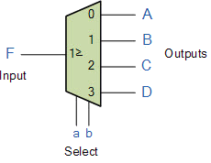  
**Figure-4:Block diagram of 1x4 De-Multiplexer**  
  
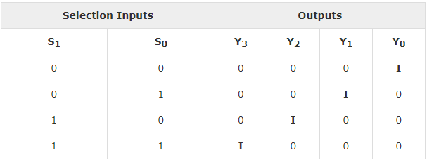  
**Figure-5:Truth table of 1x4 De-Multiplexer**